

Syntax sweets

Validation Testing Report + GitHub Link



December 13, 2024

Gabriel Peraza

Here is the GitHub link for Syntax Sweets: <https://github.com/gwperaza/SDEV140-50P-Final-Project>

Included is the program and all of its assets, as well as this validation testing report and the user’s manual.

**Validation Testing Report**

There were several instances in which I had to perform validation testing in order to ensure that the program works as intended. In this report, I’ll cover 3 such instances.

1. **Order Issue**

An issue I had noticed was that if you created an order and then restarted and created another order with different items, the second receipt would contain the items from the first one.

It would turn out that I had forgotten to erase the dictionary that hold’s the user’s items. This issue is fixed in the final version.

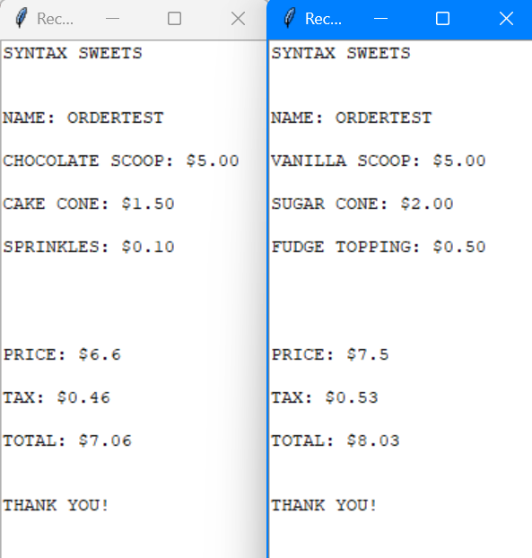

1. **Naming Issue**

Another issue I caught quite late into development is that when going through with an order and then choosing to restart and completing a second order, the second receipt would not have the user’s name on it. There were no specific entry requirements to cause this. Simply doing two orders broke the second receipt to not have the name on it.

As it would turn out, the issue actually stems from the previous issue I had. It was programmed to reset the dictionary containing the user’s order, forgetting to leave the name in. This is also fixed in the final version.

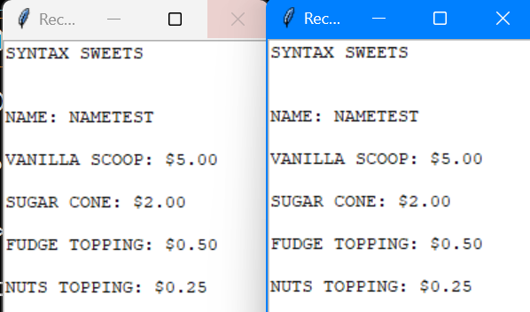

**3. Input Validation Practice**

Something I noticed rather quickly is that the input field needed proper input validation to be effective. I could detect if the field was empty just fine, but I wanted to get rid of numeric characters and symbols as well. Just about anything could be entered into the field just fine.

Luckily, in my research, I discovered the .isalpha() function, and this is what powers the program’s input validation in the final result.

